|  |  |
| --- | --- |
| **Project Case** |  |
| COMP6144  Web Programming |
| **Computer Science** | **O192-COMP6144-AH01-00** |
| ***Valid on*** *Odd Semester Year 2018/2019* | **Revision 00** |

1. Seluruh kelompok tidak diperkenankan untuk:

*The whole group is not allowed to:*

* + - Melihat sebagian atau seluruh proyek kelompok lain,

*Seeing a part or the whole project from other groups*

* + - Menyadur sebagian maupun seluruh proyek dari buku,

*Adapted a part or the whole project from the book*

* + - Mendownload sebagian maupun seluruh proyek dari internet,

*Downloading a part or the whole project from the internet,*

* + - Mengerjakan soal yang tidak sesuai dengan tema yang ada di soal proyek,

*Working with another theme which is not in accordance with the existing theme in the matter of the project,*

* + - Melakukan tindakan kecurangan lainnya,

*Committing other dishonest actions,*

* + - Secara sengaja maupun tidak sengaja melakukan segala tindakan kelalaian yang menyebabkan hasil karyanya berhasil dicontek oleh orang lain / kelompok lain.

*Accidentally or intentionally conduct any failure action that cause the results of the project was copied by someone else / other groups.*

1. Jika kelompok terbukti melakukan tindakan seperti yang dijelaskan butir 1 di atas, maka **nilai kelompok** yang melakukan kecurangan (menyontek maupun dicontek) akan di – **NOL** – kan.

*If the group is proved to the actions described in point 1 above, the score of the group which committed dishonest acts (cheating or being cheated) will be “Zero”*

1. Perhatikan jadwal pengumpulan proyek, segala jenis pengumpulan proyek di luar jadwal tidak dilayani.

*Pay attention to the submission schedule for the project, all kinds of submission outside the project schedule will not be accepted*

1. Jangan lupa untuk melihat kriteria penilaian proyek yang ditempel di papan pengumuman, atau tanya asisten anda.

*Don’t forget to look at the project assessment criteria that posted on the announcement board, or ask your teaching assistant.*

1. Persentase penilaiaan untuk matakuliah ini adalah sebagai berikut:

*Marking percentage for this subject is described as follows:*

|  |  |  |
| --- | --- | --- |
| **Tugas Mandiri**  *Assignment* | **Proyek**  *Project* | **UAP**  *Final Exam* |
| - | 100% | - |

1. Software yang digunakan pada matakuliah ini adalah sebagai berikut:

*Software will be used in this subject are described as follows:*

|  |
| --- |
| **Software**  *Software* |
| PHP Composer  PHP Storm 2017.1  XAMPP 3.22 (PHP >= 7, MySQL)  IE / Firefox / Chrome |

## Ekstensi file yang harus disertakan dalam pengumpulan tugas mandiri dan proyek untuk matakuliah ini adalah sebagai berikut:

*File extensions should be included in assignment and project collection for this subject are described as follows:*

|  |  |
| --- | --- |
| **Tugas Mandiri**  *Assignment* | **Proyek**  *Project* |
| - | Folder Project (PHP, SQL, image files (JPG/PNG/GIF), CSS, ENV, JSON, LOCK, XML, JS, CSS, SCSS, VUE, HTACCESS, TXT, ICO, CONFIG, ARTISAN, MD) |

## Soal

*Case*

General Provisions:

* Use **MySQL** asdatabase and must using **Laravel Migration** features.
* **All file upload** feature such as image and document must be **stored to server storage**.
* Use PHP Framework **Laravel 5.5** to build the project.
* Use Laravel **MVC** concept (**Model, View, Controller**) to build the project.
* Use **Eloquent Query / Query Builder** to work with database.
* You are free to design your own database table **based on the given requirements**.
* Print screen given below is only an example. You are free to create your own user interfaces.
* It is **prohibited** to install any kind of Laravel packages. You must use fresh installation of **Laravel 5.5**.
* Only **validation** in the **backend** (using Laravel) will be marked.

**Pintester**

**Pintester** is a website where people sell their arts to other users. User across the world can sells images they created or buys art images from another user as well.

As a web developer, you are asked to create a website using **Laravel** **5.5** for **Pintester**. There are three types of user’s role in this website: **Admin**, **Member**, and **Guest** (**non-logged-in user**). For each role, the website must contain at least these pages:

* + - Admin
* Home
* Cart
* My Posts
* Post Detail
* Profile
* Followed Categories
* Transaction History
* Manage Users
* Manage Categories
* View All Transactions
  + - Member
* Home
* Cart
* My Posts
* Post Detail
* Profile
* Followed Categories
* Transaction History
  + - **Guest**
* Login
* Register
* Home
* Post Detail

Each page shows **greeting to user**, and **current** **date** **time**. The descriptions for each page are:

* + - 1. **Login**

This page allows user to log in to the website. This page is **accessible only to Guest**. Display an **error message** on the login page if user enters wrong combination of **Email** and **Password**.

If user has entered correct **Email** and **Password combination**, the page will be redirected to the **Home Page** **for Member** or **Admin** based on the user’s role and if user checks the “**Remember Me**” checkbox, the website will save the **Email** and **Password** using cookies for **1 hour**.

After the user successfully **logged in** to the website, provide a **Logout** menu to **log the user out** from the website.

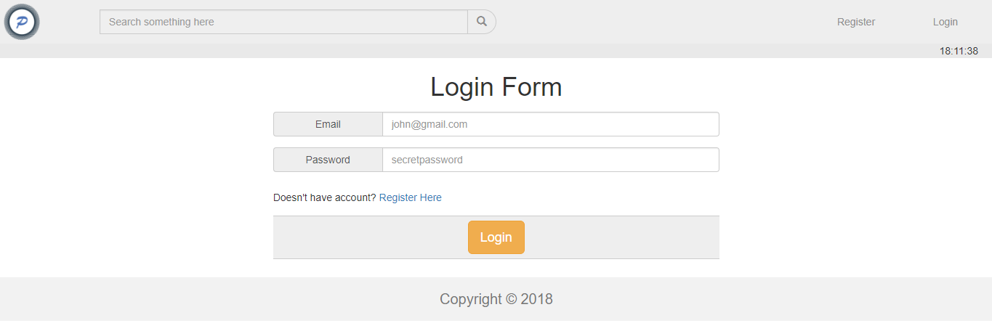

Figure 1. Login Page

1. **Register**

This page allows **Guest** to **register** themselves as **Pintester** **Member**. This page is accessible to **Guest** only. Display an **error message** if user input incorrect personal data. The following table shows the existing fields on this page and the validation for each field:

|  |  |
| --- | --- |
| **Field** | **Information** |
| **Name** | **Must be filled** with **minimum 5 characters** |
| **Email** | **Must be filled** with **email format** and **unique** |
| **Password** | **Must be filled** with **alphanumeric** and **minimum 8 characters length** |
| **Confirm Password** | **Must be filled** and **same with password** |
| **Gender** | **Must be selected** |
|  |  |
| **Profile Picture** | **Must be selected** and must **match** one of the **allowed MIME types (jpeg, png, jpg)** |
|  |  |

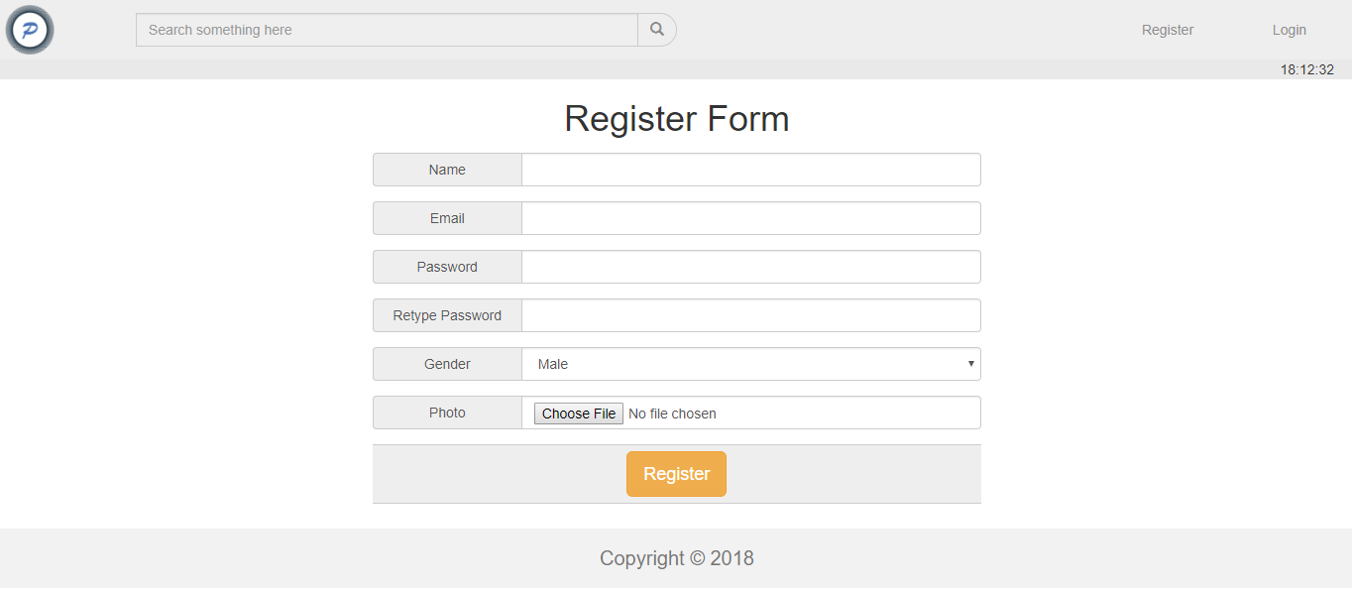

Figure 2. Register Page

1. **Home**

This page allows user to see all **Pintester user’s posts**. This page allows user to **search post by** **title or description**. This page is accessible for **all users**. Post information is displayed using **pagination** with **10** **posts** for each page. If the post is **clicked**, the page will redirect to **Post Detail** page. **Member and Admin** can choose to filter the posts by their followed categories by clicking on **Filter by My Followed Categories** link.

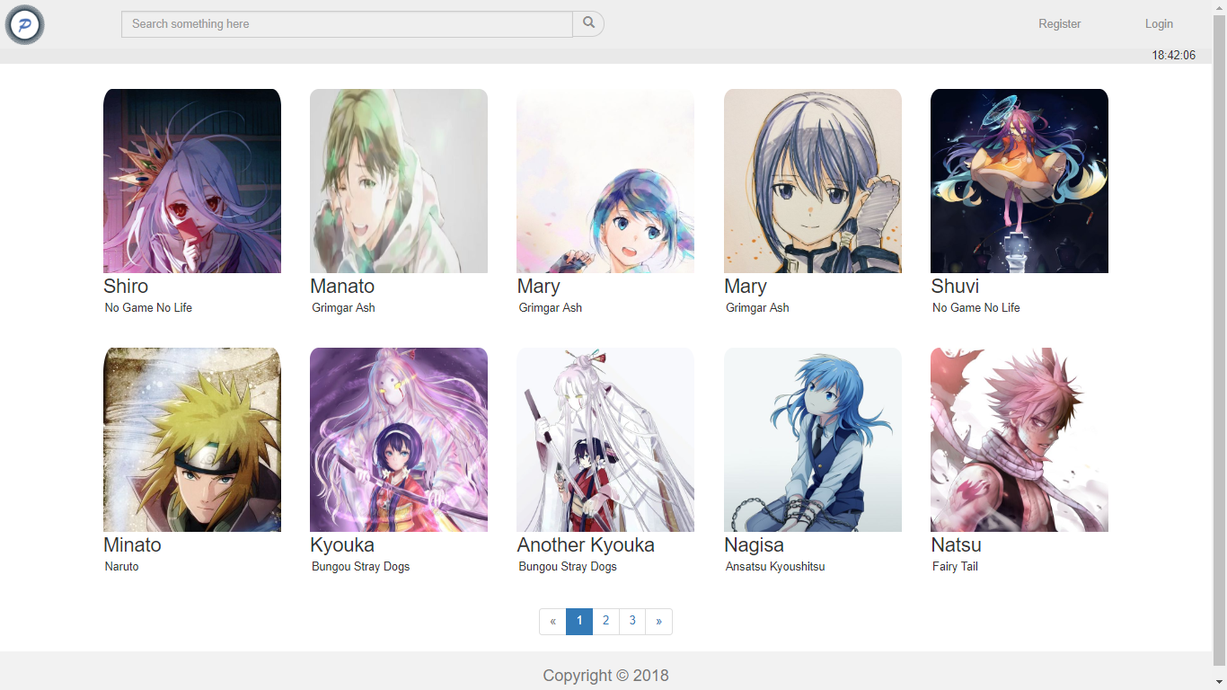

Figure 3. Home Page (for Guest)

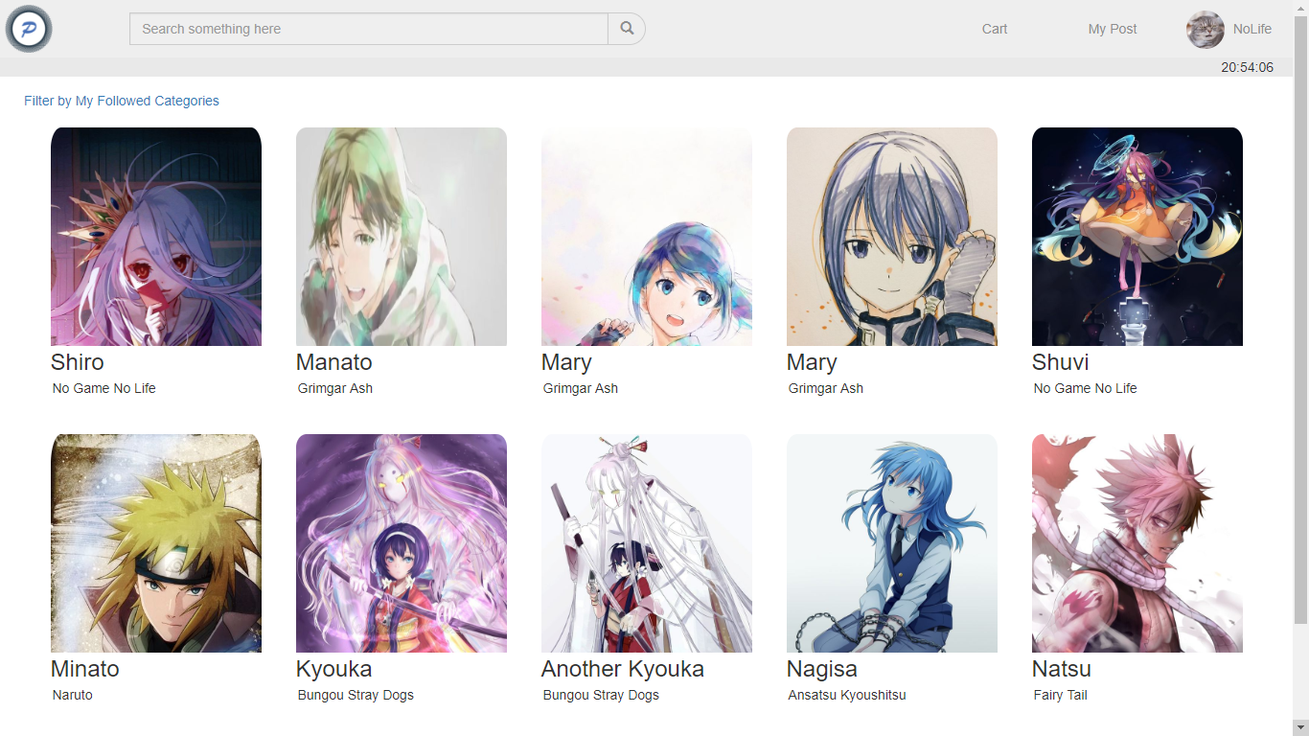

Figure 4. Home Page (for Member)

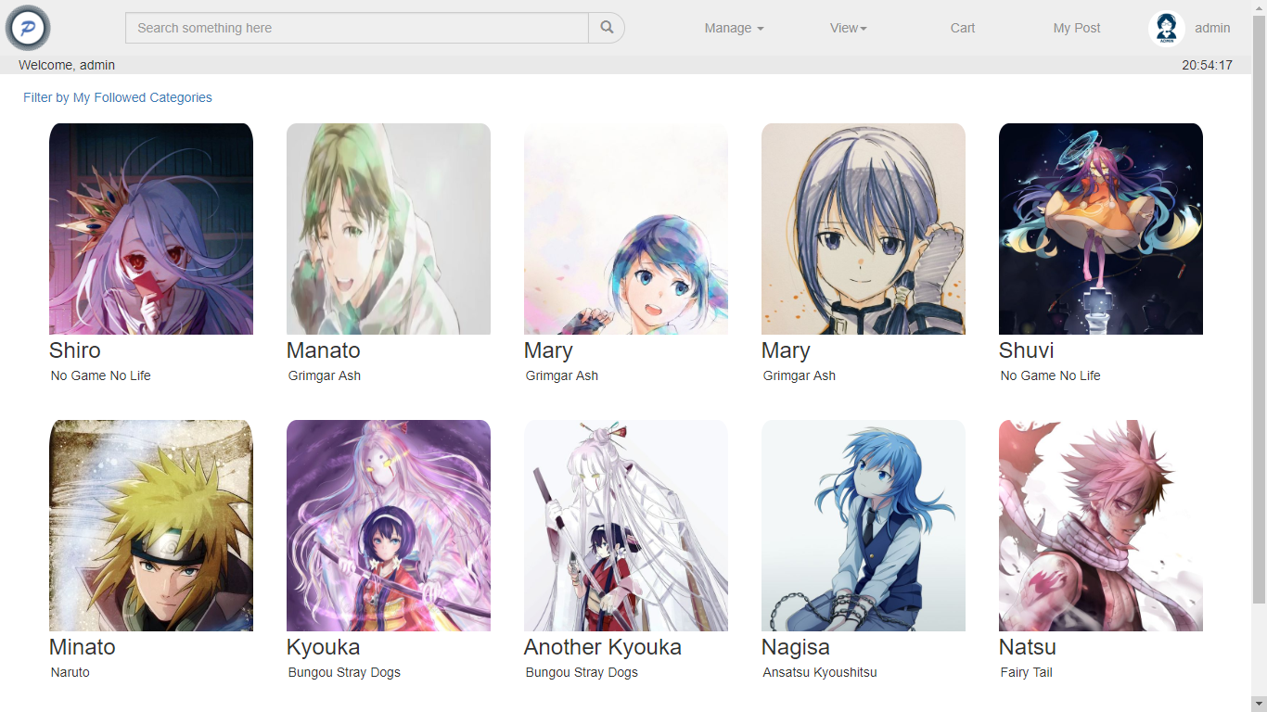

Figure 5. Home Page (for Admin)

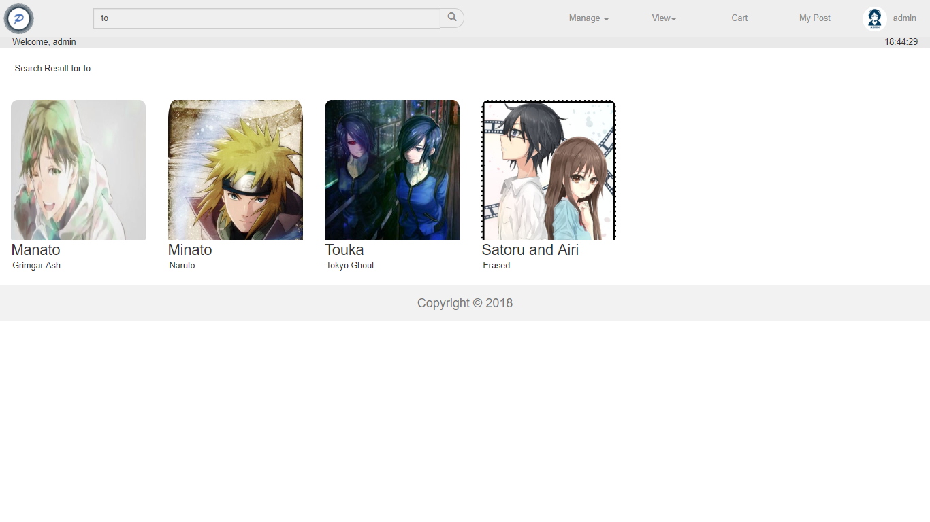

Figure 6. Searching Cake with 'to' Keyword

1. **Followed Posts Page**

This page allows **Member** and **Admin** to see all **Pintester user’s posts based on the following preferences**. Post information is displayed using **pagination** with **10** **posts** for each page. If the post is **clicked**, the page will redirect to **Post Detail** page. **Member and Admin** can back to view all posts by clicking on **View All** link.

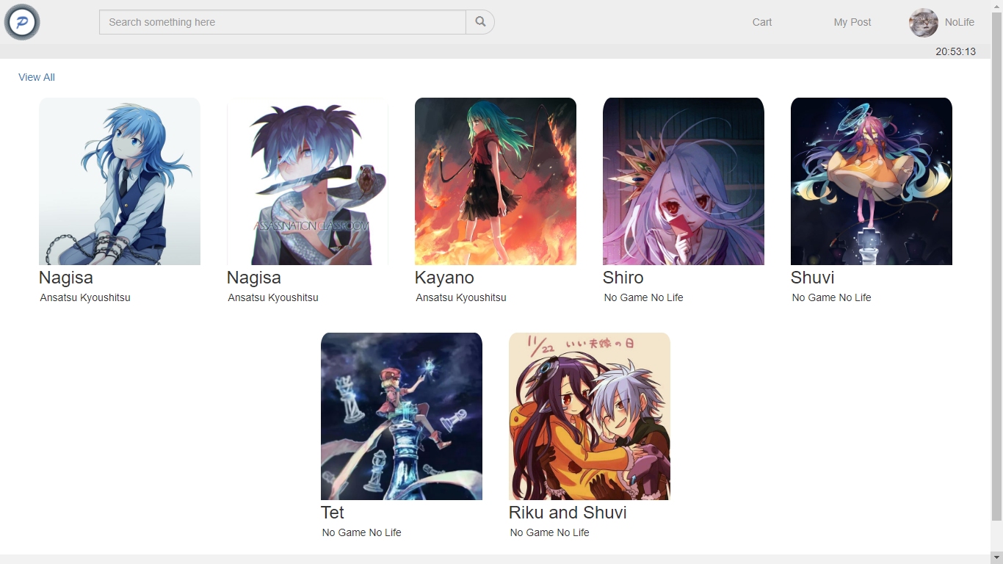

Figure 7. Followed Posts Page

1. **Cart**

This page is accessible only for **Member** and **Admin**. This page displays all posts that have been added into user’s shopping cart. Display cart information such as **Post Picture, Post Title**, **Post** **Price**, **Post Owner,** and **Total Price**.

There are two buttons in this page, **Remove** button for each product on cart and **Checkout** button. If the **user** clicks **Remove** button, then **remove product** from **cart**, and if the **user** clicks **Checkout** button, then **all shopping cart** **data** will be **deleted** and **insert** current transaction into user’s **transaction history**.

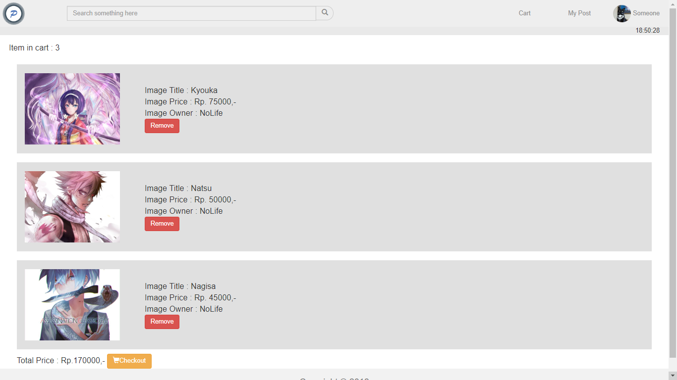

Figure 8. Cart Page

1. **My Posts**

This page is accessible by clicking **My Posts** button in header section. Validate this page only accessible to **Member** and **Admin**. This page shows all post that user has posted by using **pagination** with **5** posts per page. Each **post** can be **clicked** and redirect user to **Post Detail** page.

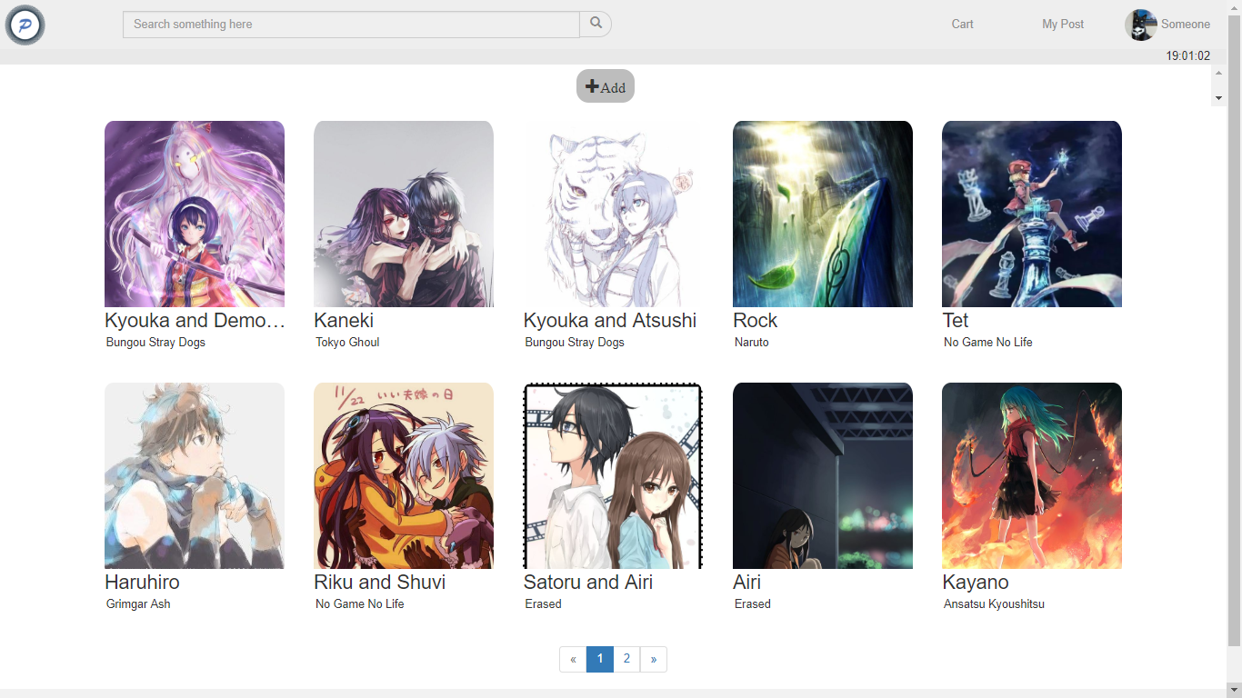

Figure 9. My Posts Page

If the **user** clicks **Add** button, redirect them to **Insert Post** page and the **user** can fill the **Insert Post Form** and click **Insert** button. Display **an** **error message** if the **user** input incorrect post data on **Insert Post Form**. The following table shows existing fields in the **Insert Post Form** and the validation for each field:

|  |  |
| --- | --- |
| **Field** | **Information** |
| **Title** | **Must be filled** and **between 20 and 200 characters length** |
| **Caption** | **Must be filled** |
| **Image** | **Must be selected** and must **match** one of the **allowed MIME types (jpeg,png,jpg)** |
| **Price** | **Must** **be filled** with **integer format** |
| **Category** | **Must be selected** |

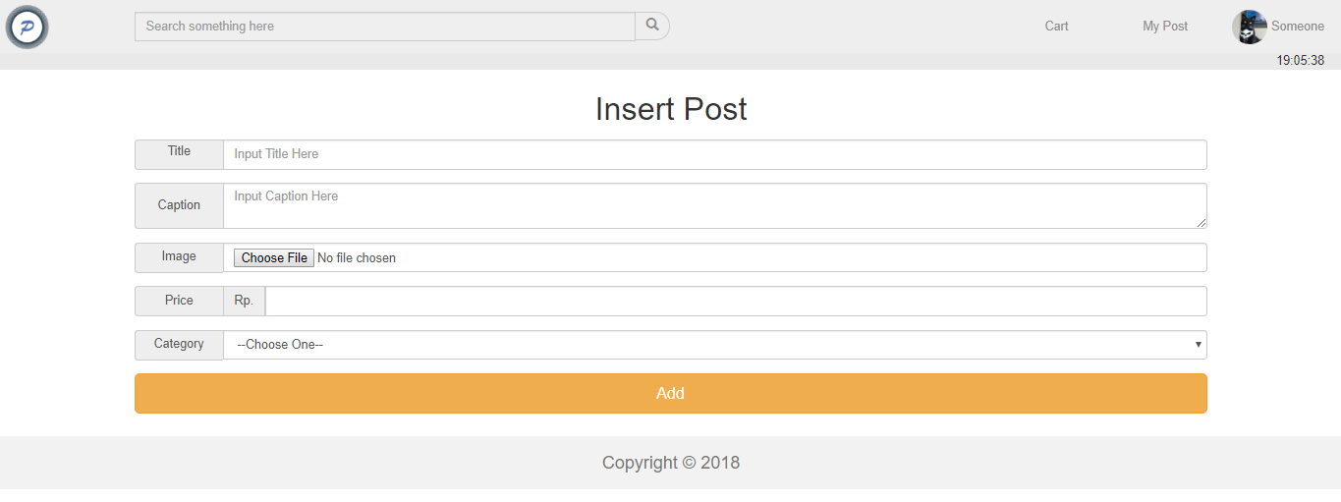

Figure 10. Insert New Post Page

1. **Post Detail**

This page is accessible for all users. This page allows user to **view** the details of a post. Display post information such as **post owner**, **post title**, **post description**, **post category**, **post picture**, **comment**, **and comment owner**.

The user can also **insert a comment** to **current post** by using the **form** below the post. The form can only appear to **Member** and **Admin**. The requirements for each field are:

|  |  |
| --- | --- |
| **Field** | **Information** |
| **Comment** | **Must be filled** |

In this page, there are ‘**Add to Cart**’ button and ‘**Delete Post**’ button:

* + - If the user clicks **Add to Cart** button, then **add the current** post into **user’s** **cart**. If the post already **exists** in **user’s cart**, then show **error message**. The **Add to Cart** button only available to **Member** **other than the post owner** or **Admin**.
    - If the user clicks **Delete** button, then **delete** the post. Delete button only available to the **Post Owner** or **Admin**.

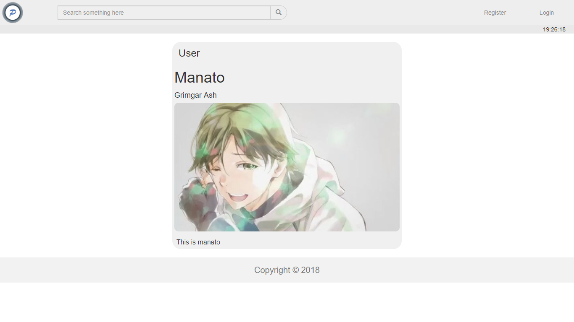

Figure 11. Post Detail (for Guest)

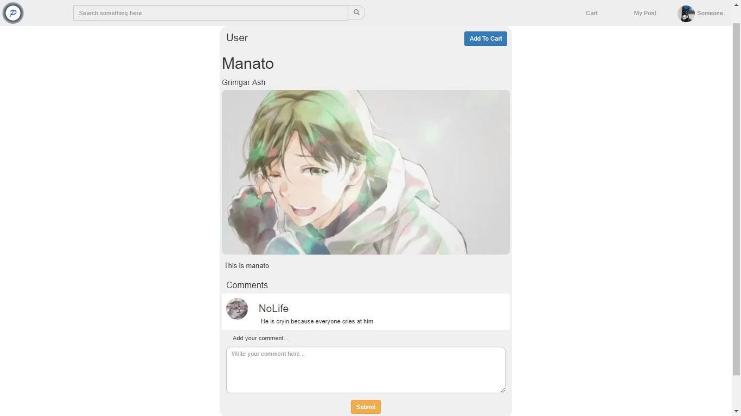

Figure 12. Post Detail (for Member Who Isn’t the Owner of the Post)

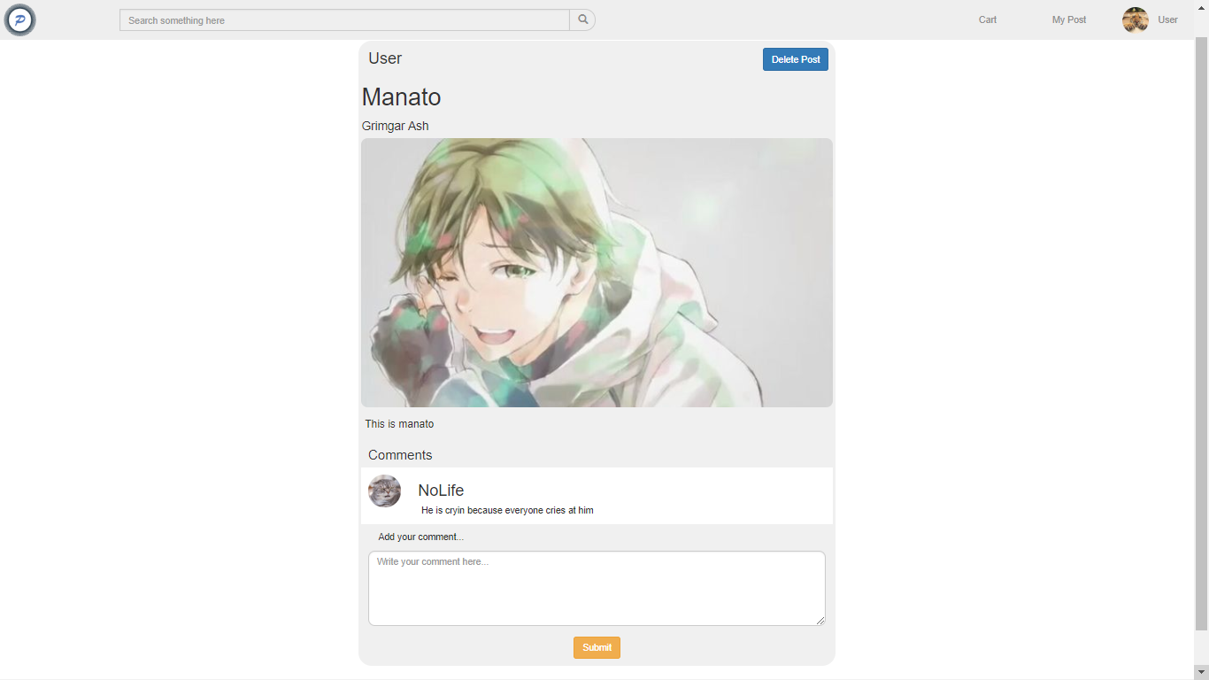

Figure 13. Post Detail (for Member Who is the Owner of the Post)

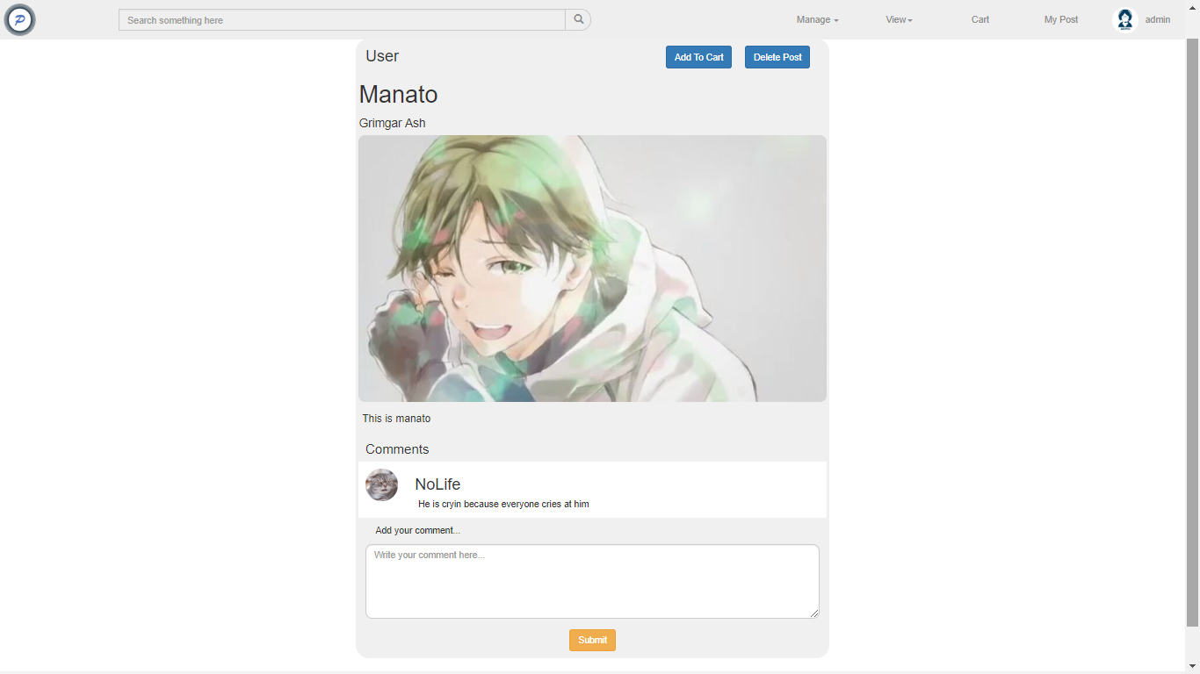

Figure 14. Post Detail (for Admin)

1. **Profile**

This page allows **Admin** or **Member** to **view** and **update** their personal data. This page will be shown if **Admin** or **Member** clicks **Profile** buttonin header section and provide **Edit Profile** button to update their personal data. This page is accessible only for **Admin** and **Member**.

Display **error message** if **Admin** or **Member** input **incorrect** personal data. The following table shows existing fields in this page and the validation for each field:

|  |  |
| --- | --- |
| **Field** | **Information** |
| **Name** | **Must be filled** with **minimum 5 characters length** |
| **Email** | **Must be filled** with **email format** and **unique** |
| **Password** | **Must be filled** with **alphanumeric** and **minimum 8 characters length** |
| **Gender** | **Must be selected** |

If **Categories** button is clicked, then redirect user to **Followed Categories page**.

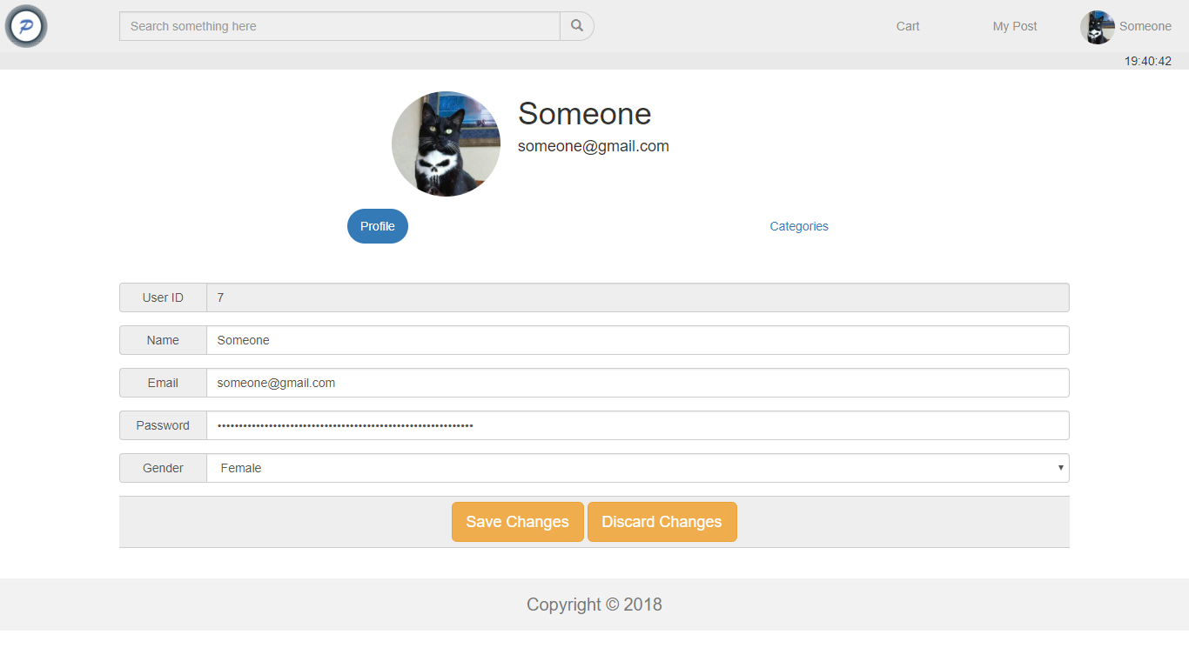

Figure 15. Profile Page

1. **Followed Categories Page**

This page allows **Member or Admin** to **update followed categories.** The page will show **all available categories** and the **following status** of **current user**. The **user** can **toggle** the following status for each category. If the **user** clicks **Submit** button, update the **Followed** **Categories**.

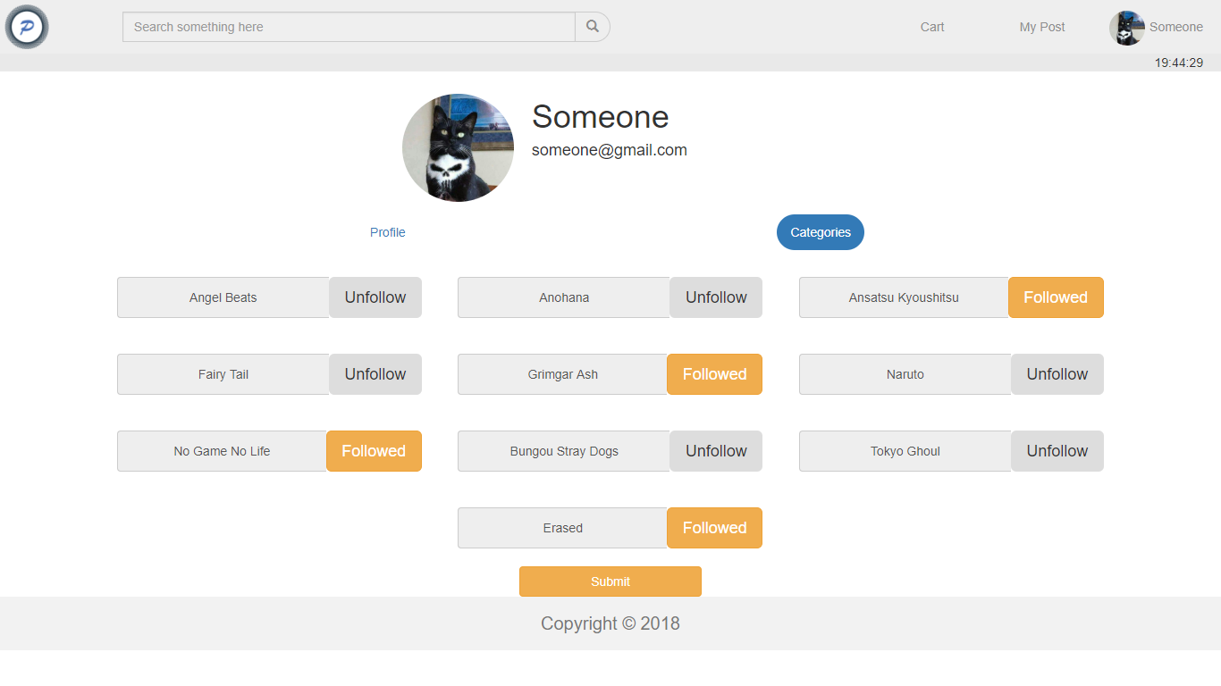

Figure 16. Choose Followed Category Page

1. **Transaction History Page**

This page shows **Member or Admin** list of transaction they had done. The information of transaction that must be shown are: **Transaction ID**, **Transaction Date**, **Buyer**, **Total Price**, **Post Image**, **Post Name** and **Post Price**.

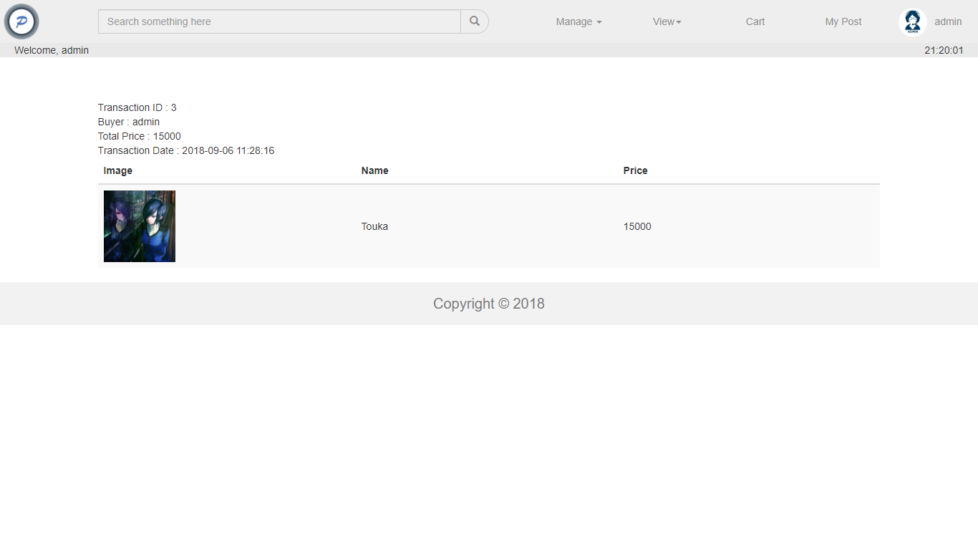

Figure 17. Show Transaction History Page

1. **Manage Users**

This page is only accessible for **Admin**. This page allows **Admin** to **view** and **edit** user that already registered in Pintester.

This page will be shown if the **Admin** clicks **Manage Users** buttonin Admin Menus dropdown at header section and provide **Edit Profile** button to update **Member’s** personal data. Display **error message** if the **Admin** input incorrect **Member**’s data.

Each user in the list have **Edit** action, if the edit action is clicked, redirect user to **Edit User** page.

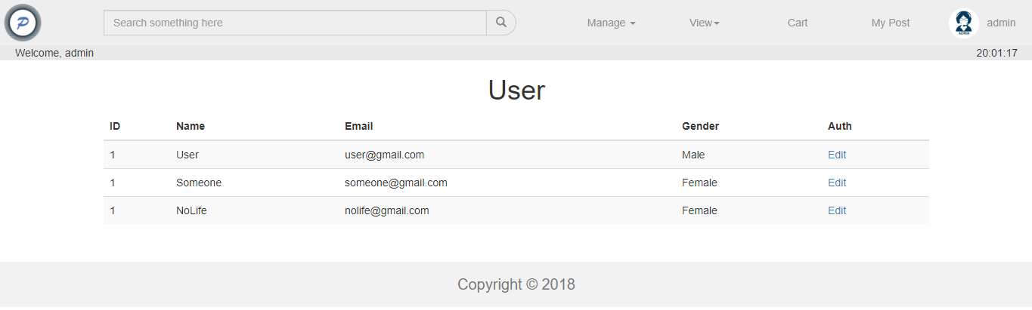

Figure 18. Manage Users Page

1. **Edit User**

This page allows the **Admin** to **update** or **delete** existing user. This section will be shown if the **Admin** clicks **Edit** link in **Manage** **Users** page. Display **error message** if the **Admin** input incorrect user’s data. The following table shows existing fields in the page and the validation for each field:

|  |  |
| --- | --- |
| **Field** | **Information** |
| **Name** | **Must be filled** with **minimum 5 characters length** |
| **Email** | **Must be filled** with **email format** and **unique** |
| **Gender** | **Must be selected** |

In this page, there are ‘**Discard Changes**’ button, ‘**Save Changes**’ button and ‘**Delete User**’ button:

* If the **Admin** click **Discard Changes** button, redirect back to **Manage User** page **without changing** the user’s profile.
* If the **Admin** click **Save Changes** button, **update** the user profile.
* If the **Admin** click **Delete User** button, **delete** the user.

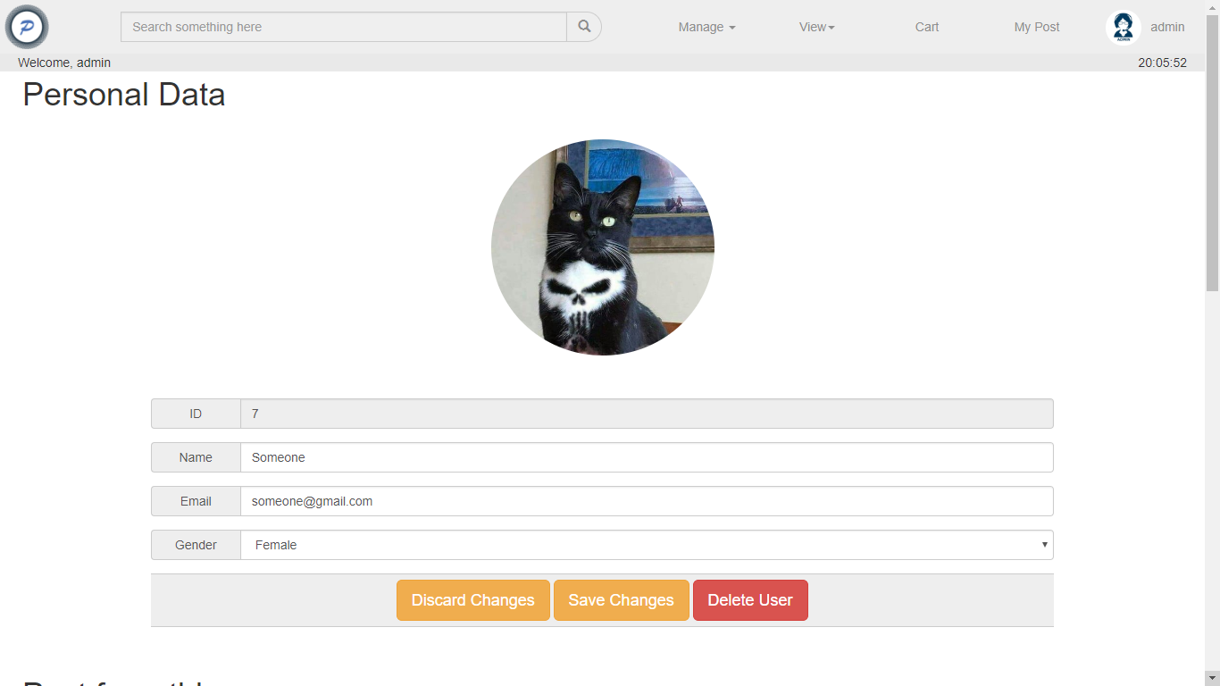

Figure 19. Edit User Page

1. **Manage Categories Page**

This section allows the **Admin** to **insert**, **update** and **delete** categories. This section will be shown if the **Admin** clicks **Categories** button under **Manage** dropdown on header section.

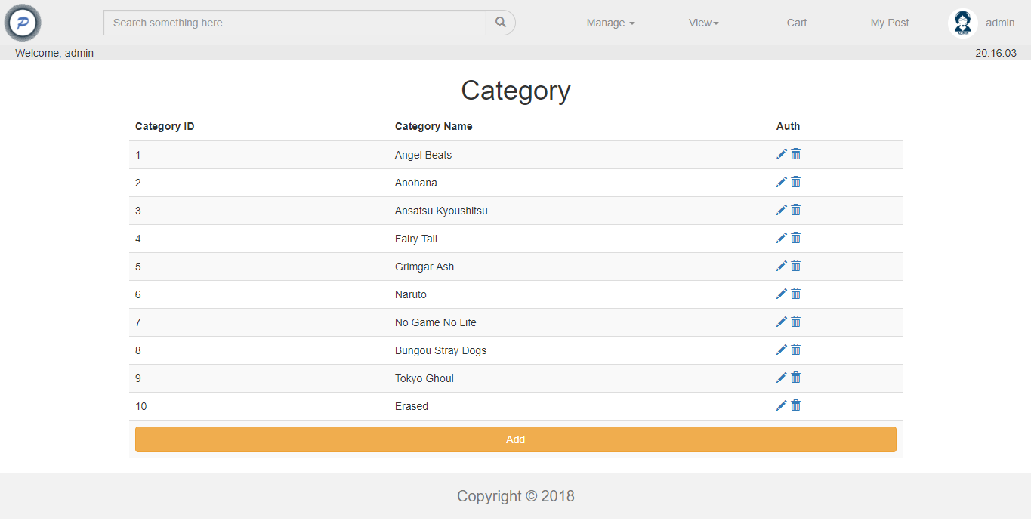

Figure 20. Manage Categories Page

If the Admin click **Add** **button**, redirect **Admin** to **Insert** **Category** page and Admin can fill the Insert Category Form and click **Insert** **button**. Display an error message if the Admin input incorrect category data on Insert Category Form.

The following table shows existing fields in the Insert Category Form and the validation for each field:

|  |  |
| --- | --- |
| **Field** | **Information** |
| **Name** | **Must be filled** with **minimum 3 characters length** and **maximum 20 characters length** |

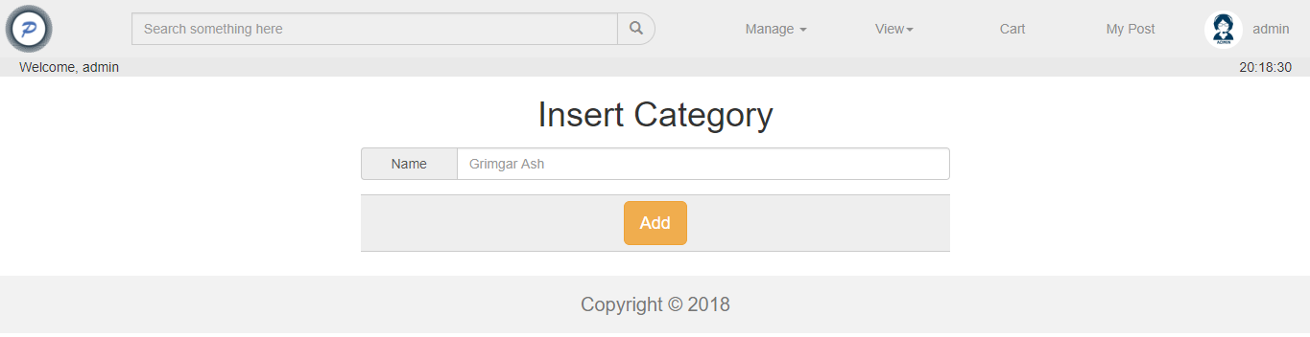

Figure 21. Add Category Page

Each category in the list have ‘**Edit**’ and ‘**Delete**’ buttons:

* If the **Admin** clicks **Edit** button, redirect **Admin** to **Update Category Page.**
* If the **Admin** clicks **Delete** button, **delete** selected category.

1. **Update Category Page**

This page allows **Admin** to update existing category. This page will be shown if the **Admin** clicks **Update** button in **Manage** **Genre** page. Display **an** **error message** if the **Admin** input incorrect genre data. The following table shows existing fields in the page and the validation for each field:

|  |  |
| --- | --- |
| **Field** | **Information** |
| **Name** | **Must be filled** with **minimum 3 characters length** and **maximum 20 characters length** |

If the **Admin** clicks **Update** button, then **update** current selected category with updated data. After that redirect **Admin** to **Manage Category** page.

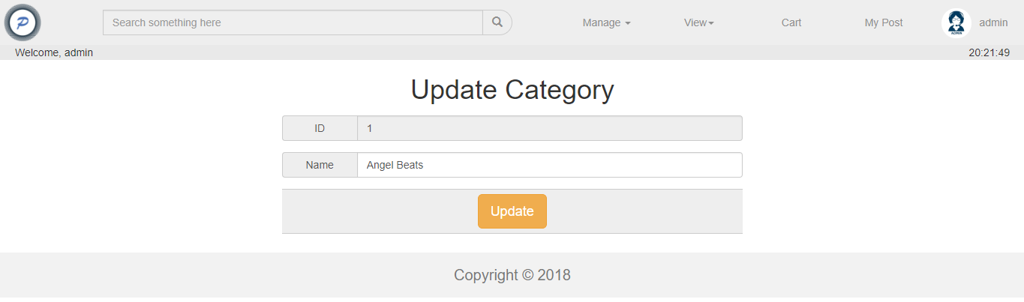

Figure 22. Update Category Page

1. **View All Transactions Page**

This page is accessible for **Admin** to **view** all transactions history. The information of transaction that must be shown are **Transaction ID, Buyer Name, Total Price, Transaction Date, Post Picture**, **Post Name**, **Post Title**, and **Post Price**.

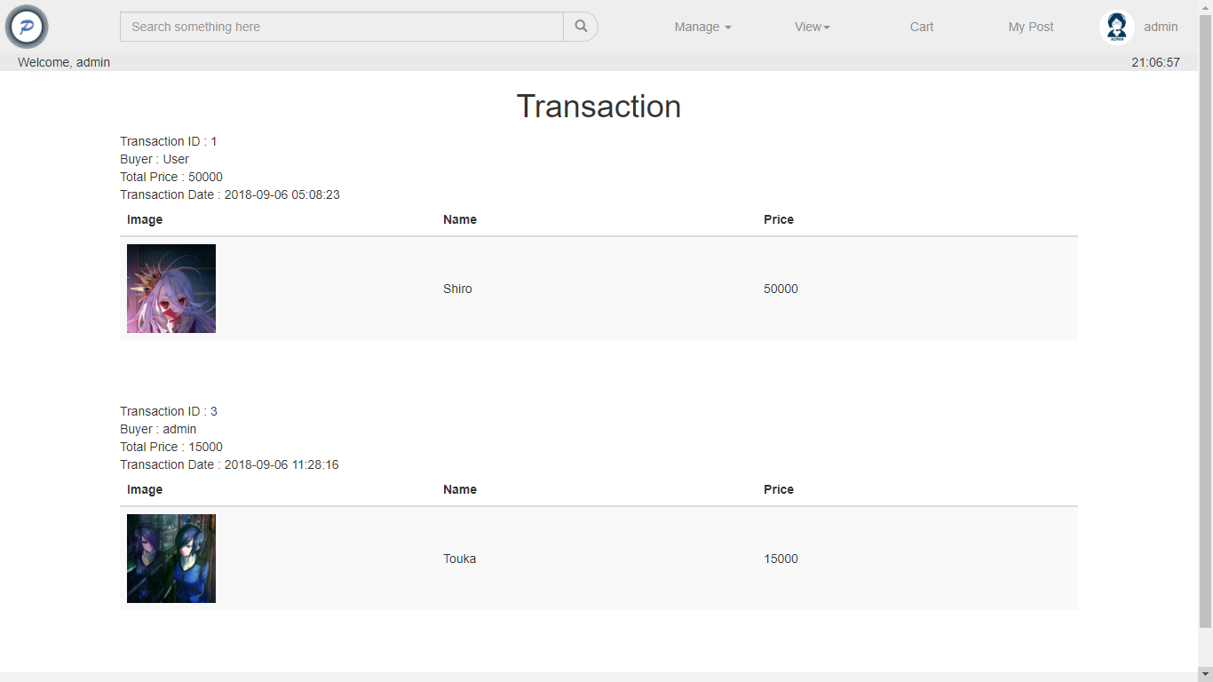

Figure 23. View All Transactions Page

Here are the rules that you must follow to create your project:

1. Use appropriate software for this subject based on **Sistem Praktikum** that can be downloaded from Binusmaya.
2. Collect appropriate files for this subject based on **Sistem Praktikum** that can be downloaded from Binusmaya.
3. Include the other files that can support your project, such as:
   * All files in your project
   * Other files (image, audio, video, etc.) used in your project
   * *.DOC file (documentation of your project) that contains all pages in your project, reference links of additional files (image, audio, video, etc.) used in your project, the description about how to use your application, etc
4. If there are some hidden creativities, please note them in the existing documentation because they can greatly affect your project score

**References**:

https://www.google.com/imgres?imgurl=https%3A%2F%2Fwww.webmedia.link%2Fsites%2Fdefault%2Ffiles%2Fpictures%2Fpicture-1-1505503146.png&imgrefurl=https%3A%2F%2Fwww.webmedia.link%2Fusers%2Fadmin&docid=im0imhruIwiQEM&tbnid=AfmgsYUn_iLbTM%3A&vet=10ahUKEwiop_bcmp7dAhULqI8KHYt0CB0QMwiOASgEMAQ..i&w=348&h=350&bih=654&biw=1366&q=Admin&ved=0ahUKEwiop_bcmp7dAhULqI8KHYt0CB0QMwiOASgEMAQ&iact=mrc&uact=8

https://id.pinterest.com/pin/526850856398490247/

https://id.pinterest.com/pin/643874077951391224/

https://id.pinterest.com/pin/111393790759339924/

https://id.pinterest.com/pin/AdAac3cM4qXBv_KmDz6dHm6lwDRnRada63nCArTNzVWdCMsJIs29uM0/

https://id.pinterest.com/pin/AY10HMRYJILBA-RenXcPzrcyRPxPJ7eLOJdKbit_Y0y70_VCuSoGuD0/

https://id.pinterest.com/pin/432204895471065488/

https://id.pinterest.com/pin/682717624734848774/

https://id.pinterest.com/pin/618541330043895494/

https://id.pinterest.com/pin/402438916683698700/

https://id.pinterest.com/pin/491033165603104779/

https://id.pinterest.com/pin/680395456176828954/

https://id.pinterest.com/pin/AZY36I5L0xULeLGnBNAsyj2KgEnZtwaVafjieFNSzbAtTN3Gbsj2NUw

https://id.pinterest.com/pin/526850856403654714/

https://id.pinterest.com/pin/649925789949614976/

https://id.pinterest.com/pin/402720391666833020/

https://id.pinterest.com/pin/817333032350287978/

https://id.pinterest.com/pin/699113542126775380/

https://id.pinterest.com/pin/146718900337958355/

https://id.pinterest.com/pin/146718900337958350/

https://id.pinterest.com/pin/745556913286594125/

https://id.pinterest.com/pin/613967361675720130/

https://id.pinterest.com/pin/796714990303914943/

https://id.pinterest.com/pin/373798837817933412/

https://id.pinterest.com/pin/797277940256016246/

https://id.pinterest.com/pin/541909767652312329/

https://id.pinterest.com/pin/602356518885812097/

https://id.pinterest.com/pin/784611566300922163/

https://id.pinterest.com/pin/43980533839076131/

https://id.pinterest.com/pin/426786502169471934/